The Leadership Assembly is a 2 ½ day foundational leadership program that is part of the Dr. Vernon O. Crawley Leadership Academy. The 2017 Leadership Assembly will take place March 29 – March 31, 2017. All Moraine Valley employees who wish to participate in this leadership development opportunity must complete and submit the Leadership Assembly Application. All Moraine Valley employees are eligible to apply. Twenty-five (25) employees will be selected from all eligible applicants. Please print the application form and forward the completed application to Matthew Piper, Manager of Staff Training and Development, in the Center for Teaching & Learning (L244) via interoffice mail no later than January 31, 2017.
The application for the Leadership Assembly is comprised of four sections. When completing sections II and III of the application, please discuss what impact the Eight Expectations of College Staff have had on your work and life experiences, as well as your other leadership endeavors. The sections are as follows:

Section I – General Information. This section is designed to gather basic information about the Moraine Valley employee applying to the Leadership Assembly.
Section II – Purpose & Experience. This section is used to better understand the applicant’s skills, abilities, and previous leadership experience.
Section III – Application Statement. This section is comprised of a short essay (300 words or less). The essay is intended to answer the questions of why he/she wishes to participate, what he/she hopes to learn about leadership, and how he/she plans to use the leadership knowledge gained from attending the Leadership Assembly.
Section IV – Signatures. Proper signatures acknowledge that the applicant has both completed the application to the best of his/her ability (Applicant’s Signature), and that his/her direct supervisor acknowledges and supports the applicant’s desire to participate in the Leadership Assembly (Supervisor’s Signature). Please note: neither the Applicant, nor the Supervisor signature guarantee acceptance into the Leadership Assembly.
The Executive Leadership Team will review all completed applications received by the deadline date of January 31, 2017. All selected applicants will be notified of their acceptance into the Leadership Assembly by February 1, 2017.
If you have any questions Regarding the Leadership Assembly or application process, please contact Matthew Piper, Manager of Staff Training and Development at X5553 or via email at piperm9@morainevalley.edu.
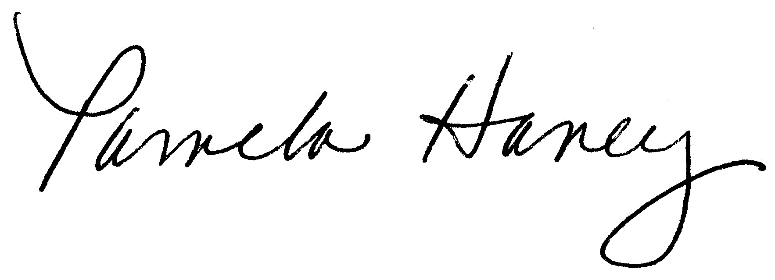
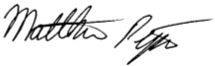
Thank you,

Dr. Pamela Haney | Matthew Piper
Vice President of Academic Affairs | Manager, Staff Training & Development

