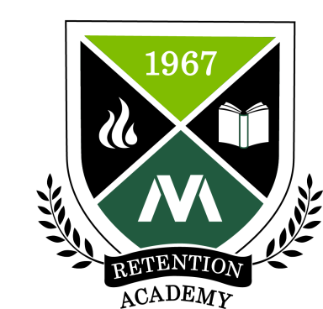 | Moraine Valley Retention Academy  Application for Single Applicant  Please print the application form and forward the completed application to  Sadya Khan, Director of Institutional Research, via interoffice mail (L150) no later than October 27, 2017.

Demographic Information
Name
Email
Phone
Position at the College
Department
Years at the College

Questions
Why are you interested in being part of the Retention Academy? (100 words or less)

Why is retention important to the work that you do at Moraine Valley? (100 words or less)

What retention-related topic or barrier would you be interested in researching for your research project in the Retention Academy? (100 words or less)

Supervisor Approval
As a supervisor of: __________________, I approve of his/her permission to participate in the Retention Academy for the upcoming calendar year. I understand that this participation includes attendance at a three-day retreat in January, followed by four mandatory meetings that will take place on Friday afternoons in the months of February through May.
Signature: | Date:

