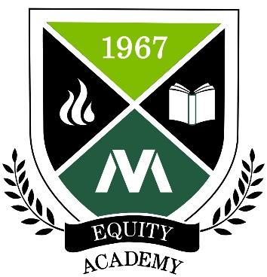 | Moraine Valley Equity Academy  Application for a Group (up to 3 members)  Please complete this digital application form and email the application to both  Dr. Sadya Khan, Director of Institutional Research (khans46@morainevalley.edu) and Dr. Kristine Christensen, Director of Faculty Development (christensen@morainevalley.edu) no later than June 4, 2021. In lieu of a supervisor signature, we also ask that your supervisor email us with the statement of support (below) by this deadline as well.

Applicant Information
Names of all applicants
Emails of all applicants
Phone of all applicants
Position at the College
of all applicants
Department of all applicants
Years at the College of all applicants

Questions
Why are you interested in being part of the Equity Academy? (100 words or less)

Why is equity important to the work that you do at Moraine Valley? (100 words or less)

What diversity, equity, inclusion-related topic or barrier would you be interested in researching for your research project in the Equity Academy? (100 words or less)

Do you plan on involving students in your project? If so, how? (100 words or less)

Supervisor Statement of Support Email
As a supervisor of: __________________, I approve of his/her permission to participate in the Equity Academy for the upcoming calendar year. I understand that this participation includes attendance at a two-day retreat in February, and six mandatory meetings that will take place during the 2021-2022 Academic Year.

